Alternating Current
A current that changes its direction periodically is called an alternating current (AC). If a current maintains its direction constant it is called a direct current (DC).
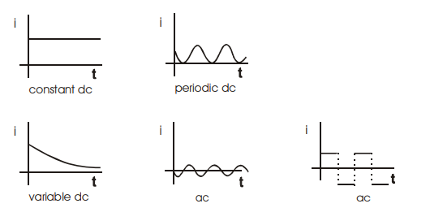
The mean value of A.C. over any half cycle (either positive or negative) is that value of DC which would send the same amount of charge through a circuit as is sent by the AC through the same circuit at the same time.
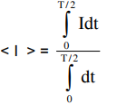
<I> = 2I₀/π where I = I₀sin(ωt)
Over a long time, this average is zero.
RMS Current: It is the value of DC that would produce the same heat in given resistance in the given time as is done by the alternating current when passed through the same resistance for the same time.
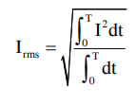
For a normal sinusoidal alternating current this I_{rms} is I₀/sqrt(2).

POWER: Consider an electrical device which may be a source, a capacitor, a resistor, an inductor, or any combination of these. Let the potential difference be V = V_{A} –V_{B} = V_{m} sin(wt). Let the current through it be I = I_{m} sin(wt + Φ). Instantaneous power P consumed by the device = VI =(V_{m} sin (wt) ) (I_{m} sin(wt + Φ)).

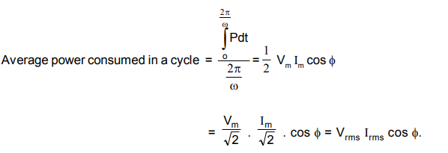
Cos(Φ) is called the power factor.

Resistive Circuit:
I_{rms} = V_{rms}/R (the derivation is in the lecture)
Thus, the current and voltage are in phase.

Inductive Circuit (pure):
I_{max} = V_{max}/X_{L} where X_{L} is the inductive reactance = ωL
The average power through the circuit is zero. (All the discussions were done in the lecture).
Current lags by π/2 over voltage.

